PE Top-Level Microarchitecture

High-Level Overview
The PE top-level module instantiates and wires together four sub-modules: the Controller (Controller), the MAC & SCALE (MAC_and_SCALE), the PPU (PPU), and the I/O Block (IO_Block). Parenthesized identifiers are the corresponding Verilog module names; the humanized forms are used throughout the remainder of this document.
All downstream decode and execution operates on sampled values. The opcode register and configuration register reside inside the Controller. The two operand registers and the output register reside inside the I/O Block.

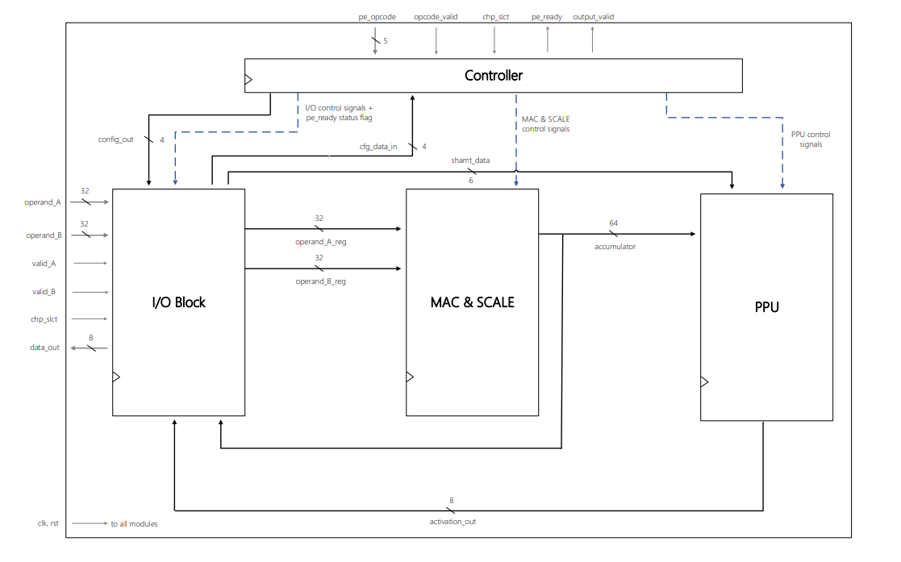
Block Diagram
Figure 1. Block-level microarchitecture.
External Interface
The external port list is defined in the PE Definition Document (Table 2).

Controller
The Controller receives pe_opcode, chp_slct, and opcode_valid from the external interface, and operand_A_reg[3:0] from the I/O Block. It produces all control signals controlling the MAC & SCALE, the PPU, and the I/O Block. It also drives pe_ready and output_valid to the external interface.
The Controller contains the opcode register, the configuration register, the SCALE FSM, and all instruction decode logic. Its internal operation is described in the Controller Microarchitecture document.

MAC & SCALE
The MAC & SCALE receives its two data operands from the I/O Block and all control signals from the Controller. It oversees all the PE's arithmetic; it contains the multipliers and adder trees used by the MAC and SCALE operations. The MAC and SCALE results are accumulated into an internal 64-bit accumulator, which is the module's output. Its internal operation is described in the MAC & SCALE Microarchitecture document.

PPU
The PPU performs the MAC post-processing. It finishes the SCALE function's right shift, and applies the configured activation function on the result. It is described in the PPU Microarchitecture document. The PPU output feeds the I/O Block.

I/O Block
The I/O Block is the data interface between the PE's external ports and its internal processing modules. It contains the two 32-bit operand input registers, a 3-bit byte-select register, the byte-select multiplexer, the output multiplexer, and the 8-bit output register. Its internal operation is described in the I/O Block Microarchitecture document.

Control Signal Description
All control signals listed below are generated by the Controller. Entries are sorted alphabetically by name.
Destination legend: C = Controller; I = I/O Block; M = MAC & SCALE; P = PPU; E = External.
Name | Dest | Description
a_is_signed, b_is_signed | M | Are operand A / operand B bytes signed: 0 — unsigned; 1 — signed.
acc_load * | M | 0 — accumulate into the accumulator; 1 — overwrite the accumulator with the first partial product result of the SCALE operation.
acc_source[1:0] | M | Accumulator source: 0 — INT4 MAC result; 1 — INT8 MAC result; 2 — SCALE partial product; 3 — bias.
acc_wr_en | M | Enables the accumulator register to capture a new value on the next rising clock edge.
act_fn_sel[2:0] | P | Activation function select: 0 — Identity; 1 — ReLU; 2 — Leaky ReLU (α = 0.25); 3 — Leaky ReLU (α = 0.015625); 4 — Tanh; 5 — Sigmoid; 6 — GELU; 7 — SiLU.
latch_en * | M | Enables capture of the current accumulator into the MAC & SCALE holding register.
mac4_iso_en | M | 0 — INT4 MAC path inputs forced to zero; 1 — INT4 MAC path active.
mac8_iso_en | M | 0 — INT8 MAC path inputs forced to zero; 1 — INT8 MAC path active.
mode4x4 | M, P | Arithmetic precision: 0 — INT8; 1 — INT4.
output_valid | E | One-cycle pulse indicating that the I/O Block output register holds a new valid result.
pe_ready | E, I | Indicates the PE can accept a new instruction. Gates operand and opcode register captures across the Controller and the I/O Block.
ppu_en | P, I | Triggers post-processing execution. In the PPU, gates the activation path inputs. In the I/O Block, selects the PPU result onto the output path and qualifies the output register write.
read_acc_en | I | Triggers an accumulator byte read. In the I/O Block, captures the byte-select index, selects the byte-select multiplexer output onto the output path, and qualifies the output register write.
read_cfg_en | I | Triggers a configuration register read. In the I/O Block, selects the zero-padded configuration value onto the output path and qualifies the output register write.
rst_acc | M | Synchronous clear of the accumulator to zero on the next rising clock edge.
scale_mode | M | Datapath select: 0 — MAC; 1 — SCALE.
scale_phase[1:0] | M | SCALE execution-cycle index (0–3). Determines which accumulator byte is processed and the bit-position alignment of the resulting partial product.
shamt_wr_en * | P | Enables the PPU shift-amount register to capture its load data on the next rising clock edge.
Table 1. PE control signals.
* latch_en, shamt_wr_en, and acc_load are driven by the same physical Controller output. They are listed as separate port names to distinguish their functional roles.

Data Bus Description
Entries are sorted alphabetically by name.
Src / Dest legend: C = Controller; I = I/O Block; M = MAC & SCALE; P = PPU; E = External.
Name | Src | Dest | Description
accumulator[63:0] | M | P, I | 64-bit signed accumulator. Feeds the PPU and the I/O Block byte-select multiplexer.
activation_out[7:0] | P | I | PPU output. Feeds the I/O Block output multiplexer.
chp_slct | E | C, I | External chip-select handshake.
config_out[3:0] | C | I | Configuration register read path. Zero-padded to 8 bits by the I/O Block, and then feeds its output multiplexer.
data_out[7:0] | I | E | PE external output.
opcode_valid | E | C | Qualifies pe_opcode as a new instruction.
operand_A[31:0] | E | I | External operand A input.
operand_A_reg[31:0] | I | M, P, C | Sampled operand A. MAC & SCALE consumes all 32 bits via port_A; the PPU is connected to bits [5:0] as shamt_data; the Controller to bits [3:0] as cfg_data_in.
operand_B[31:0] | E | I | External operand B input.
operand_B_reg[31:0] | I | M | Sampled operand B. Drives MAC & SCALE port_B.
pe_opcode[4:0] | E | C | External opcode input.
valid_A, valid_B | E | I | Qualify operand_A / operand_B as new data.
Table 2. PE data buses.

Reset Behavior
When rst is driven low, all sequential elements are asynchronously cleared to a known state. The I/O Block clears its operand registers and output register to zero. The Controller clears to its default state (opcode register to NOP, configuration register to 4'b0000, FSM to IDLE, output_valid flip-flop to zero). The MAC & SCALE clears its accumulator and holding register to zero. The PPU clears its shift-amount register to zero.
pe_ready is held low while rst is active and rises immediately upon release.

Timing Summary
All instructions except SCALE complete in one clock cycle: the opcode and operands are captured on one rising clock edge, and execution completes by the next rising edge.
SCALE spans several execution cycles. pe_ready is low throughout and rises when the FSM returns to IDLE. The cycle-accurate timing is described in the Controller Microarchitecture document.
For EXEC_PP, READ_ACC_BYTE, and READ_CFG, output_valid pulses one clock cycle after decode. data_out is stable and valid on that cycle.

